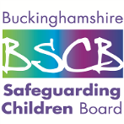
Buckinghamshire Safeguarding Children Board
Escalation, Challenge and Conflict Resolution: Procedure
Appendix B: Named Officer for Advising on Conflict Resolution
Updated December 2016

Named Officer for Advising on Conflict Resolution
Please enter names and contact details for your organisation
Name of organisation / service area

Named senior for the organisation’s internal conflict resolution | Name: | Position: | Contact details:  Tel:  Mob:  Email:
Named senior for inter-agency/organisation conflict resolution | Name: | Position: | Contact details:  Tel:  Mob:  Email:
Named senior for allegations against staff or volunteers | Name: | Position: | Contact details:  Tel:  Mob:  Email:

