Multi-Agency Child Exploitation Protocol

Appendix 1 – Child Exploitation Indicator Tool

Buckinghamshire BSCP
Child Exploitation Indicator Tool

Guidance
This Indicator Tool aims to help practitioners focus on the specific exploitation indicators and determine whether further investigations are needed by Children’s Social Care and Thames Valley Police. This tool therefore informs both assessment of need and referrals to Children’s Social Care. This tool should be attached to your Children’s Social Care referral regarding a potential CSE or other exploitation case.
The Exploitation Indicator Tool can be used by any professional working with children under the age of 18, whilst we appreciate some adolescents prefer the term young people for the purpose of this document, we will refer them to children.
Often children themselves do not recognise themselves as victims or that they are being groomed, and as a result, disclosures of such abuse can be unlikely. Therefore, this indicator tool aids the identification of exploitation.
Practitioners need to exercise their own professional judgment when completing the tool because factors such as the child’s age, any additional vulnerabilities, their history etc. may mean that they are more vulnerable to exploitation. Professional judgment also includes capturing concerns about which they have some evidence AND concerns based on ‘their gut feeling’. Staff should differentiate between the two and explain this in the ‘comments/evidence/description’ sections.
Once completed, where child exploitation is suspected the worker should follow local safeguarding procedures. Remember, Children’s Social Care is responsible for assessing the level of risk to children. Should the referral not meet Children’s Social Care’s threshold, other support options will be considered including Early Help and referrals to appropriate services.
If you suspect anyone is in immediate danger, call the Police on 999.
Please note that this document will be shared with statutory agencies in order to safeguard children with the strict understanding that it is only used for that purpose.
Child’s Details
Child’s name:
Date of birth:
Childs Address:
Ethnicity:
School / College:
Is this child looked after? | Yes c No c
Do they live in residential care? | Yes c No c
Are they placed at a distance? | Yes c No c

Your Details
Your name
Job title
Contact details
Which agency are you from?
Date completed:

Information Sharing and Disclosure
Is child aware that this tool has been completed? | Yes c No c
Are Parents/Carers aware that this tool has been completed? | Yes c No c
Who else has contributed to the completion of this indicator tool? (child, parent/carer, school…)

Has the child made a disclosure of exploitation (abuse)?
Current c Yes c No c If ‘Yes’ you must refer to Children’s Social Care immediately
Historic c Yes c No c If ‘Yes’ you must refer to Children’s Social Care to determine current risk
Are the people who may be grooming or exploiting the young person:
Known to the child? | Yes c No c Unknown c
A family member? | Yes c No c Unknown c
(If you answer Yes to either of the above questions please state who this person is)

Names of the child’s friends/sibling/other who you think might be affected by exploitation also:

Risk Indicators
- Health Domain Health to check | Yes (Y) / No (N) | Current (C) / Previous (P)
  - Physical injuries such as bruising suggestive of either physical or sexual assault
  - Sexually transmitted infection (STI), including recurring infections or multiple STI's
  - Pregnancy and / or seeking a termination/emergency contraception
  - Accessing contraception outside of ‘normal’ amounts.
  - Poor self-image and low self-esteem
  - Self-harming
  - Thoughts of or attempted suicide
  - Eating disorder and /or weight gain/loss
  - Evidence of misuse of drugs / alcohol, including associated health problems
  - Physical and/or learning disability or difficulty
Health Comments/Evidence/Description of ‘YES’ indicators
E.g. Indicator 1.8 – child/young person is attending substance misuse project and has disclosed heavy cannabis use

- Behaviour Domain | Yes (Y) / No (N) | Current (C) / Previous (P)
  - Risk taking behaviour without recognising the impact or consequences
  - Truancy / at risk of exclusion / missing education / on reduced timetable or considerable change in performance at school
  - Volatile behaviour exhibiting extreme array of mood swings or abusive language which is unusual for the child
  - Aggressive or violent including to animals, parents, siblings, teachers or peers
  - Becoming angry, hostile if any suspicions or concerns about their activities are expressed
  - Detachment from age-appropriate activities
  - Secretive behaviour
  - Change in appearance (not including weight changes)
  - Young offender or anti-social behaviour including petty crime
  - Changes in relationships with families or family members
Behaviour Comments/Evidence/Description of ‘YES’ indicators

- Grooming Domain | Yes (Y) / No (N) | Current (C) / Previous (P)
  - Entering or leaving vehicles driven by unknown adults
  - Excessive use of mobile phones including receiving calls late at night
  - Possession of a second mobile phone or sim card
  - Exposing or recruiting other children into exploitative situations
  - Seen in adult places (i.e. pubs and clubs) or venues known to be used for exploitation or criminal activity
  - Unexplained relationships with older adults
  - Associating with other children who are known to be exploited, including in school
  - Sexual relationship with a significantly older person
  - Disclosure of sexual /physical assault followed by withdrawal of allegation
  - Phone call, texts or letters from unknown adults
  - Mobile phone being answered by unknown adult / person
  - Inappropriate use of the Internet and forming relationships, particularly with adults (they may appear to be peers), via the Internet.
  - Social activities with no plausible explanation of the source of necessary funding
  - Having keys to premises other than those they should have including hotel key cards
  - Possession of money, clothes, accommodation or other expensive items with no plausible explanation
  - Adults loitering outside the child’s usual place of residence or school
  - Persistently missing from home or placement for different periods, including overnight or returning late
  - Returning after having been missing and being secretive about where they have been and who they were with
  - Returning after having been missing looking dirty, disheveled, tired, hungry, thirsty
  - Abduction or false imprisonment
  - Coerced into sexual activity
  - New contacts with people outside of town
Grooming Comments/Evidence/Description of ‘YES’ indicators

- Family and Social Domain | Yes (Y) / No (N) | Current (C) / Previous (P)
  - A family member or known associate working in the adult sex trade or criminal/drug activity
  - History of physical, sexual and / or emotional abuse; neglect
  - Witness to domestic violence/abuse at home
  - Parental difficulties; drug and alcohol misuse, mental health problems, physical or learning difficulty. Child is a young carer.
  - Pattern of street homelessness or sofa surfing
  - Living in hostel, B & B or Foyer accommodation
  - Conflict at home around boundaries, including staying out late.
  - Living in a gang affected neighbourhood
  - Recent bereavement, loss, family separation and/or family breakdown.
  - Are parents protective?
  - Gang association either through relatives, peers or intimate relationships
  - Intelligence to suggest that they carry weapons
  - Lacking friends their own age
  - There are cultural factors that impacts their vulnerability
  - Going missing with other children
Family and Social Domain Comments/Evidence/Description of ‘YES’ indicators

- E Safety Domain | Yes (Y) / No (N) | Current (C) / Previous (P)
  - Evidence of vulnerability through internet or social networking sites
  - Concern that inappropriate images of a child are being circulated via the internet / phones
  - Concern that the child is being coerced/bribed/threatened to provide explicit images/engage in inappropriate online activity
  - Concern that the child is being paid for sexual acts online
  - Accessing on-line dating/‘hook-up’ sites
  - Unexplained increased use of social networking, shared gaming sites and / or receiving rewards/credits.
  - Going online during the night
  - Being secretive using mobile phone for accessing websites etc. including unwillingness to share / show online or phone contacts
  - Concern that a child is having an online ‘relationship’
  - Concerns that a child’s online friendship has developed into an offline ‘relationship’
E-Safety Comments/Evidence/Description of ‘YES’ indicators

When considering exploitation, the following domains are helpful to consider:
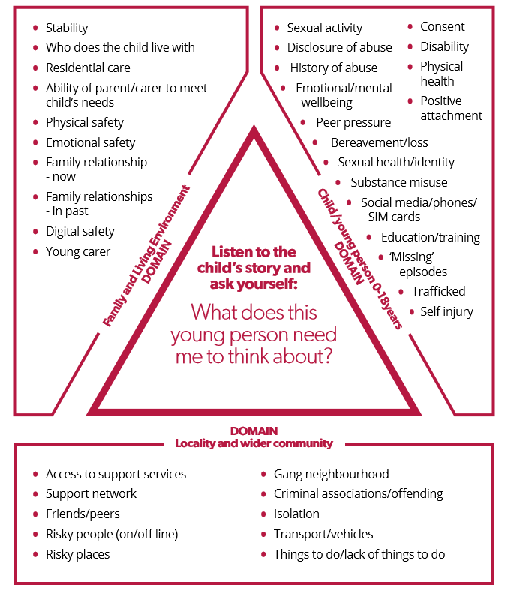
Summary of Any Concerns
It is important you complete all of this section
Total number of concerns identified:
Current
Historic
Your analysis and overview (a few sentences to indicate your thinking):

Specific planned or completed actions as result of tool completion:

Which agencies/workers are involved with this child/family?
I
Has an NRM been completed previously? Please attach / provide details

What type of exploitation has been identified through completion of the indicator tool;
CSE currently not a factor at this time/concerns relate to age appropriate behaviors
Evidence² of vulnerability to sexual exploitation
Evidence² of being groomed (including on-line) or targeted for the purposes of sexual exploitation
Evidence² of being groomed into membership of a criminally active gang
Evidence² that child is being sexually exploited
Evidence² of drugs exploitation
Evidence² of other modern day slavery

