Multi-Agency Child Exploitation Protocol
Appendix 5 - Contextualised Safeguarding - Staff Guide

Please note this is not an exhaustive list of things to consider and you are encouraged to speak to the Exploitation Hub for further support if needed.

What is Contextual Safeguarding?

Contextual Safeguarding is an approach to understanding, and responding to, young people’s experiences of significant harm beyond their families. Traditional approaches to protecting children/young people from harm have focussed on the risk of violence and abuse from inside the home, usually from a parent/carer or other trusted adult and don’t always address the time that children/young people spend outside the home and the influence of others on young people’s development and safety.
Contextual safeguarding recognises the impact that the different relationships young people form in their neighbourhoods, schools and online have on their lives, and consequently their safety. This approach seeks to identify and respond to harm and abuse posed to young people outside their home, either from adults or other young people considering how different interventions can change the processes and environments, to make them safer.

To understand how we work in Buckinghamshire, please refer to the Exploitation Protocol

When I am working with a child at risk of exploitation, have I considered…?

Area to consider | What is it? | How to consider in casework?
Have I consulted with the Exploitation Hub at the earliest possible opportunity to explore what my concerns are re: exploitation? Refer to Exploitation Protocol. | The hub is there to offer you support and guidance on at the earliest opportunity you identify concerns of exploitation. | Hub has a duty worker on every day and can offer advice, support and guidance by way of a consultation. This is recorded on the system by the Exploitation Hub worker providing guidance on how best to progress the case. This could include support to progress a referral into MACE, advice on further information required or guidance on how to refer into the National Referral Mechanism (NRM).  Prompt questions  Am I concerned this young person is susceptible to being exploited?  Do they display certain vulnerabilities – e.g learning needs?  Would it be helpful to have a reflective discussion with someone who has expertise / knowledge in this area of contextual safeguarding?
Have I explored Push and Pull factors which are linked to children who are exploited? | Pull factors, are factors which can pull a child towards exploitation. This can be children performing tasks for others resulting in them gaining things such as, accommodation, food, gifts, status or a sense of safety, money or drugs. Often the hook is through the perpetrator supplying Class B drugs such as cannabis to the child or young person.  Push factors are factors which push a child away from their environment and closer towards exploiters. Children escaping from situations where their needs are neglected and there is exposure to unsafe individuals, where there is high family conflict or the absence of a primary attachment figure. | When considering risk factors for children it is important to understand these as “push and pull factors” as it allows the professional to gain insight into why the young person may end up being exploited and how they may be able to achieve these “pull” factors by alternative means.  Prompt questions  For example, have we talked to the child about what will make them feel safe? What is their understanding or definition of safe?  Do they have financial difficulty in their home? (pull factor)  Are they suffering from or witnessing domestic abuse within the family home? (push factor)  Examples of pull factors (not exhaustive list)  Wanting freedom and independence  Being made to feel special by grooming for potential sexual exploitation or child trafficking  Fear of repercussion for self or family if they don’t go  Feeling “wanted”  Examples of push factors (not exhaustive list)  Not feeling accepted or wanted in their environment  Family breakdown  Mental health problems  Low Self esteem
Have I thought about what language I am using to describe the child or the situation? | Secondary Victimisation / Language  Language that victimises and blames children, and often places responsibility to “resolve” the issue of exploitation on the child themselves.  Examples of language used in case work reviewed included;  - “streetwise”  - “drug running”  - “putting herself at risk of exploitation” | Language should reflect the presence of coercion and the lack of control children have in abusive or exploitative situations. Victim-blaming language may reinforce messages from perpetrators around shame and guilt. This in turn may prevent the child from disclosing their abuse, through fear of being blamed by professionals. When victim-blaming language is used amongst professionals, there is a risk of normalising and minimising the child’s experience, resulting in a lack of appropriate response.  Prompt Questions  If someone else was to read the file, would it imply it is the childs “choice” these things are happening?  Have I tried to reframe the language I would use by using the tools below?  Have I linked the risks being identified to the exploiter?  Have I asked what the childs behaviour is trying to communicate?  What is their unmet need based on previous and historical lived experiences and trauma?  Alternatives you can use when writing about children;  Appendix 2 ‘Exploitation Protocol Tool’ of the Multi-Agency Child Exploitation Protocol, offers alternatives  NWG (National Working Group – Exploitation)  Victim Blaming Language - NWG Network  Trauma informed Language  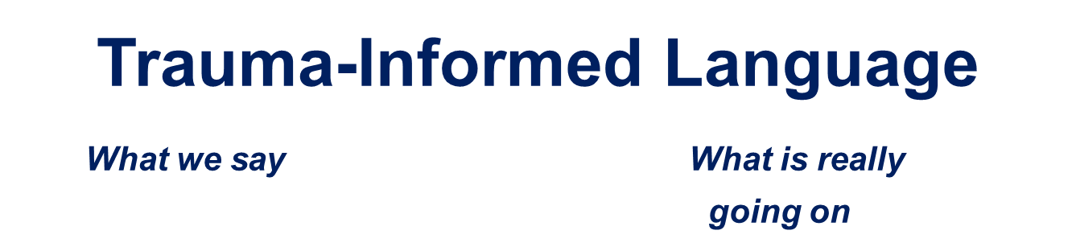  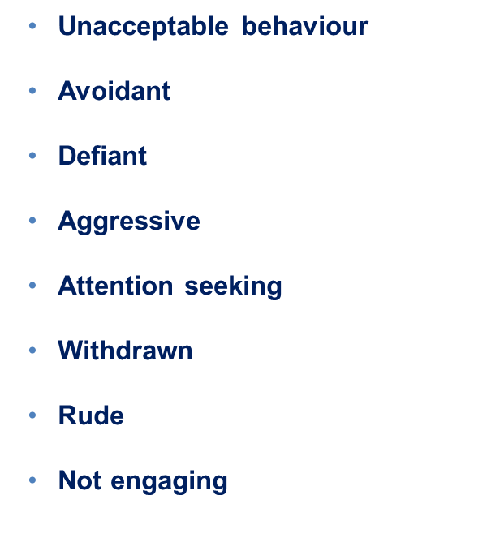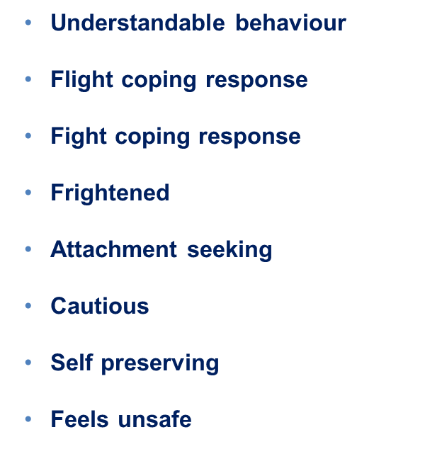
Have I tried to build a “meaningful relationship with this child?” | Depending on the context in which a trusted relationship is being built, it has been suggested that resilience and outcomes can be improved through:  - Encouraging a child to persevere when they are struggling with something  - Giving them a safe and non-judgmental space in which to challenge and explore things that they may be concerned about or not agree with  - Exposing them to alternative possibilities and perspectives, which can help to raise their aspirations and broaden their options  - Enabling a child to realise that the issue they are dealing with is ‘not okay’, and to raise their awareness about the risks associated with a particular situation or behaviour  - Helping children to feel less isolated, as they come to understand that they can share a problem or concern and ask other trusted people to help them overcome it. | A trusted relationship is fundamental to the successful delivery of a service which depends on the effective engagement of a vulnerable child. It has been described as being key to achieving a successful outcome for a child, and to ensuring that children are confident about discussing their concerns and disclosing issues.  Below are some suggestions which may assist in developing meaningful relationships (This is not an exhaustive list)  - Regular contact with the child for “no reason” except to ask how they are through text or call. (This should be outside of statutory visits and any “expected” discussions)  - Asking open ended questions “Tell me about yourself?”  - Reinforcing to child your interest in them as a person “I didn’t know that, that’s really interesting”  - Involving the child in “setting the agenda” for meetings and visits. This means being clear about what is non-negotiable and what is negotiable. For example, “You know I want to come and see you, and will do that, but you tell me what time / day is good for you?”. “What would you like to do when I come and see you?” “You tell me what you want to talk about”  - Suggesting doing something together, before asking questions, and explaining to the child or young person that the most important thing is to “get to know each other”  - Allowing the child or young person to pick perhaps where they see you  - Allowing the child to identify an activity to do with you.  Useful articles  adversity-and-trauma-informed-practice-guide-for-professionals.pdf (youngminds.org.uk)  Trauma and Relationships | Out of Home Care Toolbox (oohctoolbox.org.au)
Have I thought about how my plan reflects appropriate management of risks? | Risk management / safety planning should focus on contextual and external factors within the childs community and extended network of peers and not solely on the child and family themselves. If the risks presented are extra familial – these are the areas that need to be mitigated against.  We need to think about how we can support the child to feel safe which could increase their resilience and be an important factor in extracting them away from exploiters. | Risk and safety planning is key to ensuring young people who are at risk of extra familial harm are kept as safe as possible. This is only achieved through good multi agency working and engagement of partners, both universal and targeted to support the management of risk.  Prompt Questions  Does my case summary show the risk management / safety plan needed for any immediate risks?  Does my CIN / CP plan reflect who is going to support management of risk contextually? Who are the partners that can assist?  Have I referred to MACE? Have I reflected how MACE is supporting / managing contextual risks within my plan?  Is information being effectively shared, and so that each agency can respond appropriately?  Have multi-agency actions been identified and agreed in order to intervene promptly to reduce risk  Has risk to all children been considered – e.g. siblings?  What can other agencies do to support disruption?  Child exploitation disruption toolkit (publishing.service.gov.uk)
Is my plan inclusive of those who can contribute to the contextual intervention? | This means thinking about who can support in the community including parents. Youth workers, professionals at school, places of worship a child may be connected to. | In order to manage extra familial harm, those within the community need to play a key role in supporting delivery of the intervention.  Prompt questions  Have we included the key people in the child's network into the plan?  What do the people who are part of the child's network need to know?  What role could other play in safety planning?  How are we supporting parent / carer / other professionals involved to understand what the risks are?  What role can the education setting play (if child is at school)
Have I demonstrated professional curiosity and thought about the analysis? | Professional curiosity for children who are at risk of / being exploited should demonstrate a need to try and understand the underlying value base of the child. | Professional curiosity should not be limited to only eliciting information from the child / family it may be to probe further with other partners or agencies to gain an increased understanding of the childs context.  Example of professional curiosity  A young person appearing to be under the influence of cannabis, reported by placement as missing. Worker visits child and discusses the missing episode but does not discuss the possible use of cannabis, their views on cannabis and whether they knew where to get it from.  If explored fully with open ended questions this could have provided the worker with opportunities to understand more about what the child understands about exploitation, drug use, what their views were around drug use, if they know how to access it? What did the child understand to mean by the term “gangs” or being “affiliated to gangs”?.  Prompt questions  “How is this childhood trauma manifesting itself in adolescent behaviour that is being seen today?  What can we hypothesise that this may be about? Attachment? Historic neglect? Identity?”  “What is the unmet need for this child?”  E.g. “XX is more susceptible to being exploited because of xxx which happened in their life”. This then would benefit from being underpinned by research regarding exploitation.
Have I sought research to underpin any hypothesis that are being held about push and pull factors? |  | Research can support to underpin hypothesis regarding children that we may hold as professionals involved in trying to understand the child / family and their current and historical context. It is of particular importance in children who are at risk of exploitation due to the everchanging nature of how exploiters will operate to coerce vulnerable children.  Prompt questions  Has the hub been contacted to explore what research may support you to understand more about the risks that are being presented to the child?  Where can I go to get research or learn more?  https://contextualsafeguarding.org.uk/ - free to sign up several resources available  Protecting children from county lines | NSPCC Learning  The Child Safeguarding Practice Review Panel - It was hard to escape - report (publishing.service.gov.uk)  Criminal Exploitation of children and vulnerable adults: County Lines guidance (publishing.service.gov.uk)
Have I considered submitting a police intel report? | Police intel is essential to submit when thinking about children who are at risk of or have been exploited. | The purpose of police intel can support in identifying information which can be used to rule in or rule out police activity. Each intel report is reviewed by police and located on a specific system, the police can then have a “birds eye” view of risk factors that may be being shared. You can always consult with the Exploitation Hub about the appropriateness of submitting an intel report. Intel reports do not solely need a strategy meeting to take place and can be submitted at any time.  Prompt questions  If the young person has shared some information with me, could this be relevant to wider risk factors presented to the child which I may not be aware of?  Have I consulted with the hub about the appropriateness of submitting intel if I am unsure?  Briefing on what should and should not be submitted – Guidance from TVP  Example Police Intel Form

